**A picture containing clipart

Description generated with very high confidence**

MODULE-7 ASSIGNMENT

Microsoft Azure AZ-203 Training Course

[**support@intellipaat.com**](mailto:support@intellipaat.com)

**+91-7022374614**

**US: 1-800-216-8930(Toll Free)**

**Topic:** Image uploading on Azure blob storage

**Description: Azure Blob storage is Microsoft's object storage solution for the cloud. Blob storage is optimized for storing massive amounts of unstructured data. Unstructured data is data that does not adhere to a particular data model or definition, such as text or binary data.**

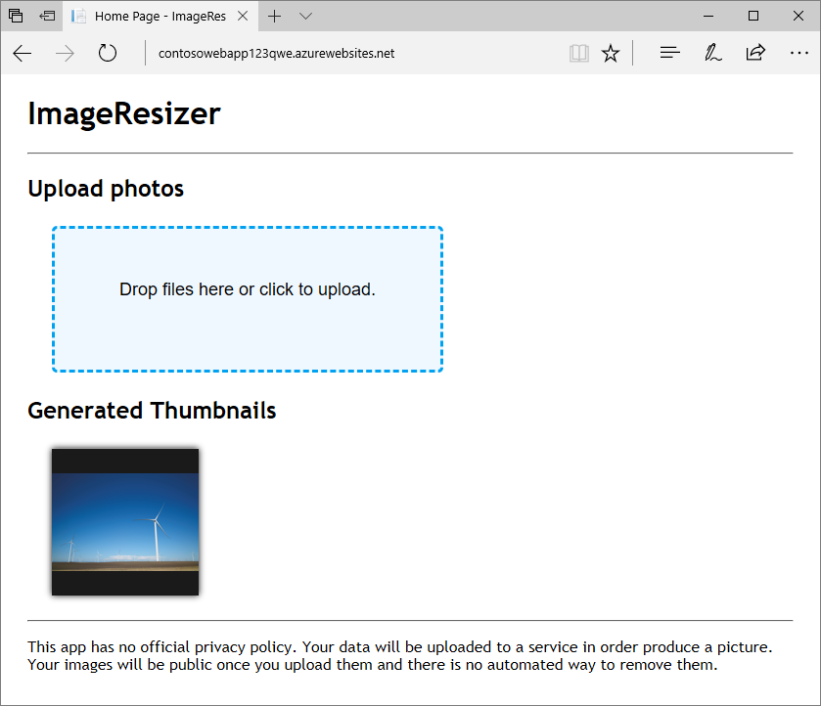

**Problem Statement:** Upload image data in the cloud with Azure Storage

**Steps to be performed:**

* Open Azure Cloud Shell
* Create a resource group
* Create a storage account
* Create Blob storage containers
* Create an App Service plan
* Create a web app
* Deploy the sample app from the GitHub repository
* Configure web app settings
* Upload an image
* Verify the image is shown in the storage account
* Test thumbnail viewing